<Shopping Application>

Analysis and Design Document

Student:Jidvean Dragos

**Group:30642**

Revision History

|  |  |  |  |
| --- | --- | --- | --- |
| **Date** | **Version** | **Description** | **Author** |
| <dd/mmm/yy> | <x.x> | <details> | <name> |
|  |  |  |  |
|  |  |  |  |
|  |  |  |  |

Table of Contents

I. Project Specification 4

II. Elaboration – Iteration 1.1 4

1. Domain Model 4

2. Architectural Design 4

2.1 Conceptual Architecture 4

2.2 Package Design 4

2.3 Component and Deployment Diagrams 4

III. Elaboration – Iteration 1.2 4

1. Design Model 4

1.1 Dynamic Behavior 4

1.2 Class Design 4

2. Data Model 4

3. Unit Testing 4

IV. Elaboration – Iteration 2 4

1. Architectural Design Refinement 4

2. Design Model Refinement 4

V. Construction and Transition 5

1. System Testing 5

2. Future improvements 5

VI. Bibliography 5

# Project Specification

Proiectarea si implementarea unei aplicatii client-server care care poate fi folosit pentru a face cumparaturi online. Actorii principali ai sistemului sunt: Clientul, Administratorul

Clientul poate face urmatoarele operatii:

* Sa vizualizeze produsele
* Sa verifice pretul produselor
* Sa isi faca cont nou
* Sa cumpere produse

Administratorul poate face urmatoarele operatii:

- Sa inregistreze clienti noi

- Sa se ocupe de intretinerea si configurarea sistemului

- Sa rezolve posibilele erori

# Elaboration – Iteration 1.1

# Domain Model

Modelul de domeniu se refera la modelul conceptual care incorporeaza atat comportamentul cat si datele prezente in proiect.

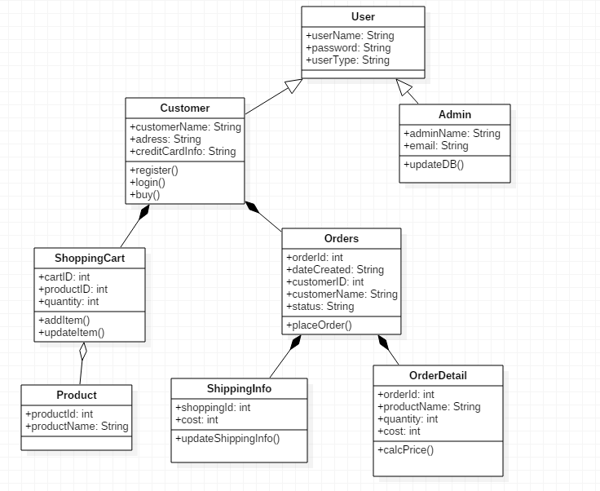

# Architectural Design

## Conceptual Architecture

Proiectul va fi implementat utilizand sablonul architectural Layers, care este avantajos din punct de vedere al portabilitatii, testarii, fiecare nivel poate fi reutilizat individual.

Sunt 3 nivele :

Presentation Layer - contine functionalitatile principale referitoare la utilizatori, pentru gestionarea interactiunii dintre utilizatori si sitem

Business Layer – implementeaza functionalitatile principale ale sistemului

Data Acces Layer - realizeaza conexiunea cu baza de date

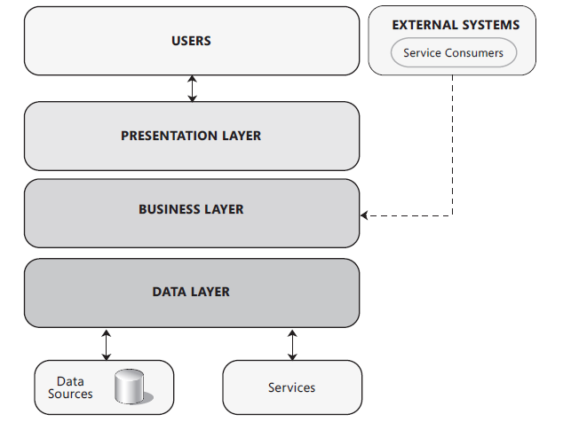

## Package Design

**

## Component and Deployment Diagrams

# 

# Elaboration – Iteration 1.2

# Design Model

## Dynamic Behavior

*[Create the interaction diagrams (1 sequence, 1 communication diagrams) for 2 relevant scenarios]*

## Class Design

*[Create the UML class diagram; apply GoF patterns and motivate your choice]*

# Data Model

*[Create the data model for the system.]*

# Unit Testing

*[Present the used testing methods and the associated test case scenarios.]*

# Elaboration – Iteration 2

# Architectural Design Refinement

*[Refine the architectural design: conceptual architecture, package design (consider package design principles), component and deployment diagrams. Motivate the changes that have been made.]*

# Design Model Refinement

## *[Refine the UML class diagram by applying class design principles and GRASP; motivate your choices. Deliver the updated class diagrams.]*

# Construction and Transition

# System Testing

*[Describe how you applied integration testing and present the associated test case scenarios.]*

# Future improvements

*[Present future improvements for the system]*

# Bibliography